# 5. User Interface Design

This section provide snapshots for the E-menu user interface.

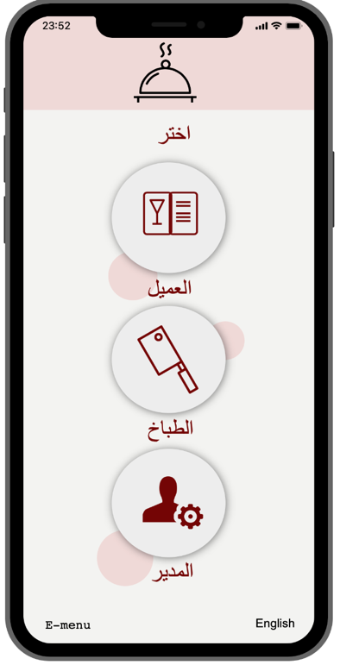

This is the first interface in the app where you can select Characteristics.

And from this page you can select the

The language.

Snapshot.1 Snapshot.2

if you select chef or admin will show you the log in page to log in.

Snapshot.3

in this page you will choose if the order is dain in or take out.

Snapshot.4

in this page there 5 button, first button is menu to view the menu, the second is to show your order, the third button is to call the waiter if you need any think, the fourth is to print your bill, and the last button if you have any complaints.

Snapshot.5

this page show you the menu , the price, rate, category, and the name of the dish.

Snapshot.6

This page show you all of your order .

Snapshot.7

Here is your bill and also you can pay from here if you need cash or card.

Snapshot.8

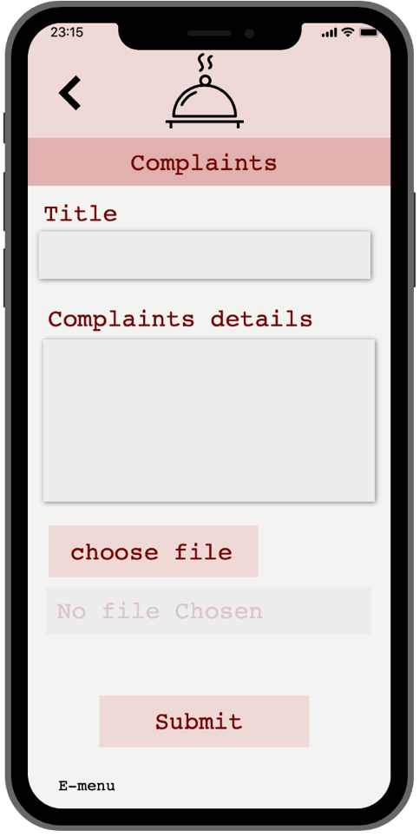

In this page if you have any complaints you can write your problem and if you have a photo you can attach it and submit the complaints.

Snapshot.9